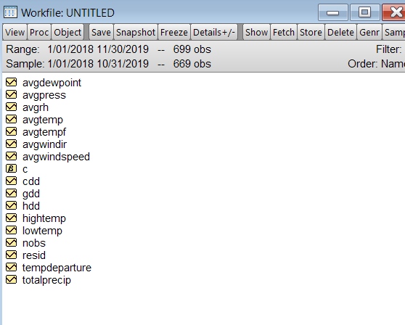

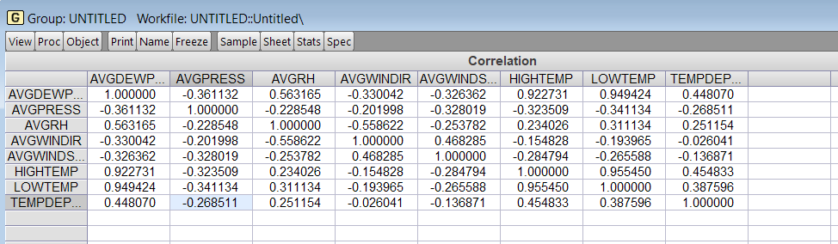

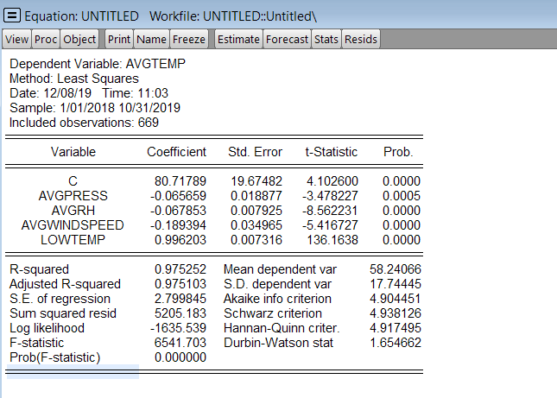

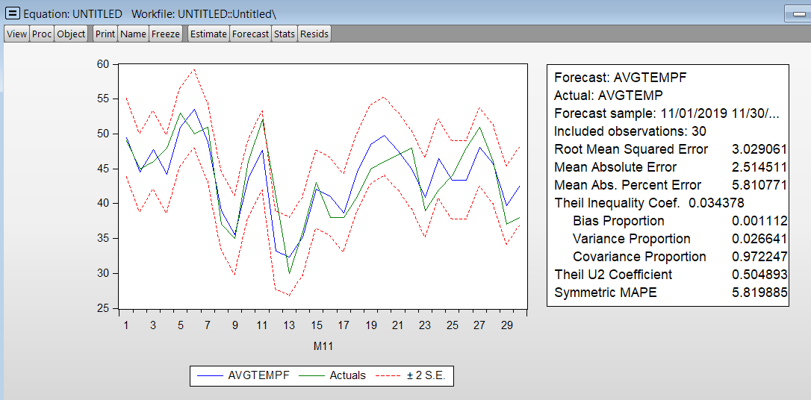

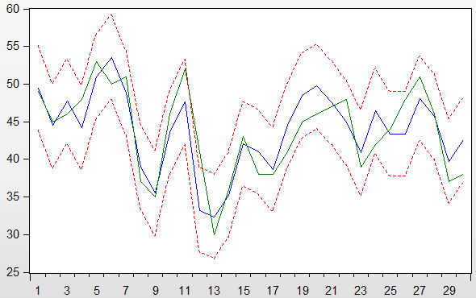

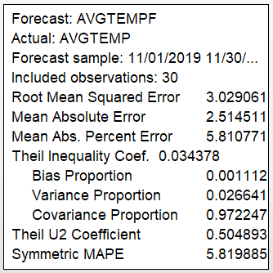

With quarter

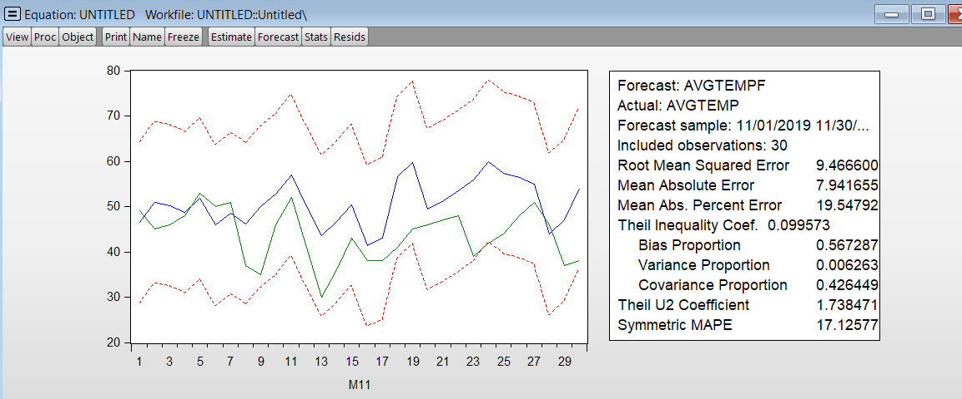

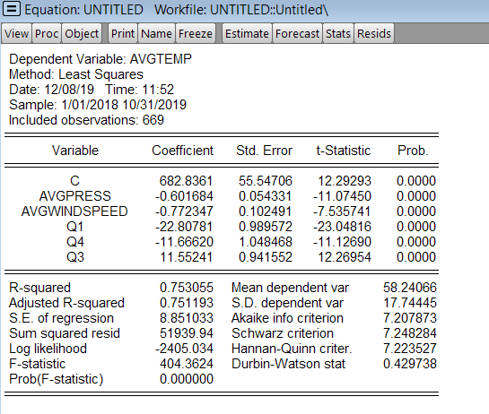

Estimation Command:

=========================

LS AVGTEMP C AVGPRESS AVGWINDSPEED Q1 Q4 Q3

Estimation Equation:

=========================

AVGTEMP = C(1) + C(2)*AVGPRESS + C(3)*AVGWINDSPEED + C(4)*Q1 + C(5)*Q4 + C(6)*Q3

Substituted Coefficients:

=========================

AVGTEMP = 682.836111473 - 0.60168443759*AVGPRESS - 0.772346973655*AVGWINDSPEED - 22.8078148958*Q1 - 11.666197393*Q4 + 11.5524129785*Q3

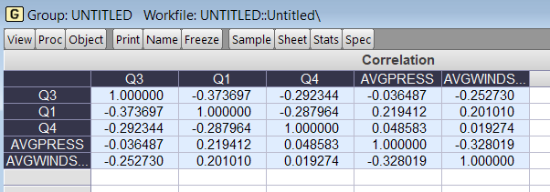

ARIMA

Take 1st order differencing. Model:

diff c ar(1) ar(2) ar(10) ma(1) diff(-365)

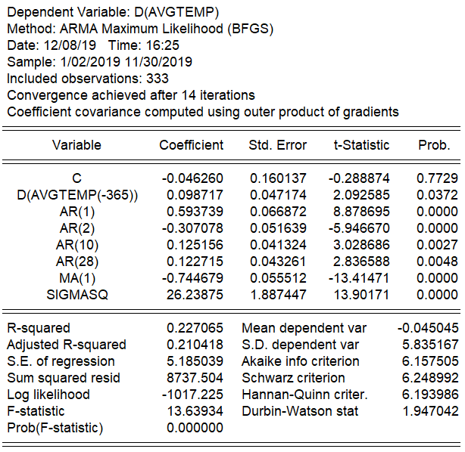

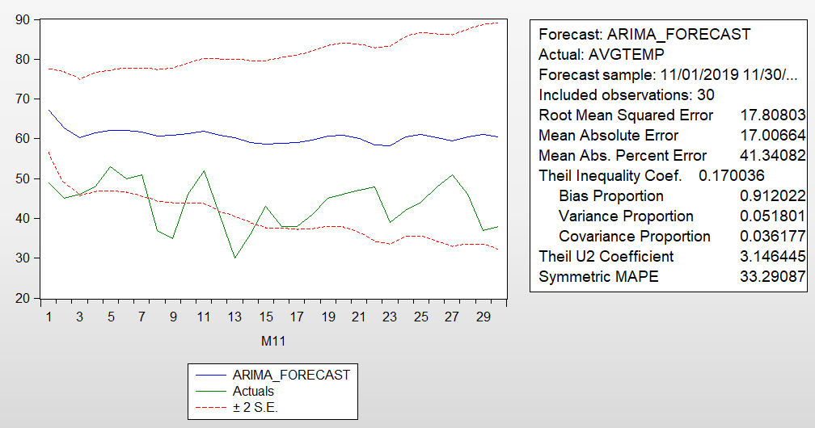

avgtemp c lag_avgdewpoint lag_avgpress lag_avgrh lag_cdd lag_gdd lag_hdd lag_totalrecip lag_windir lag_windspeed

**New regression with lagged variable**

